CW
- Router Config

- Router 0
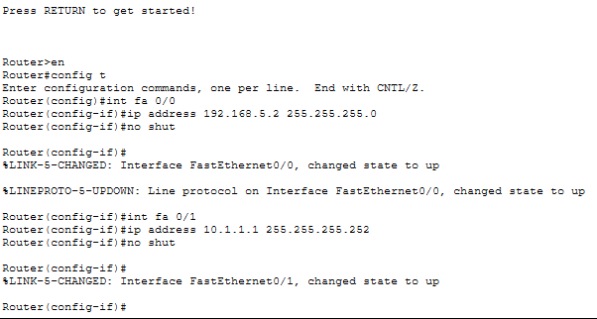
- Router 1

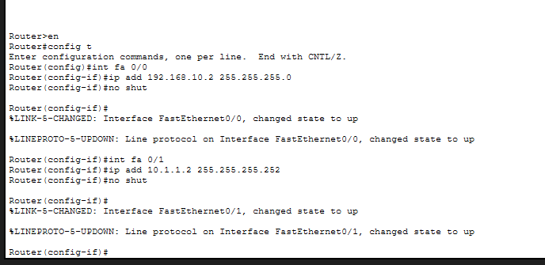

- OSPF

- Router 0
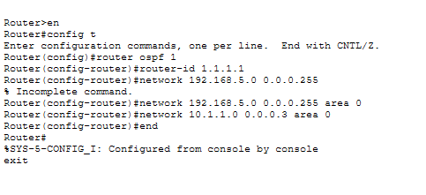
- Router 1
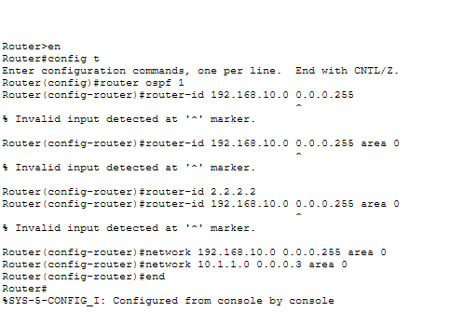

HW
- Router Config

- Router 2
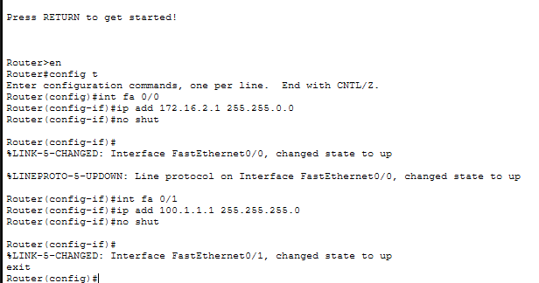
- Router 3
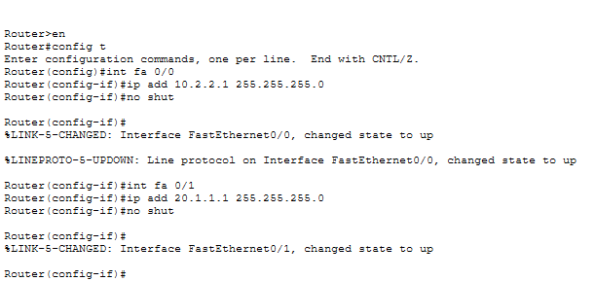
- Router 4
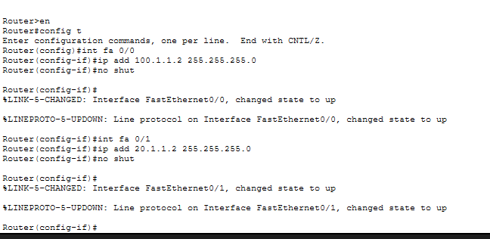

- OSPF

- Router 2
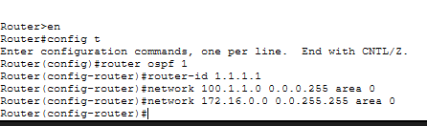
- Router 3
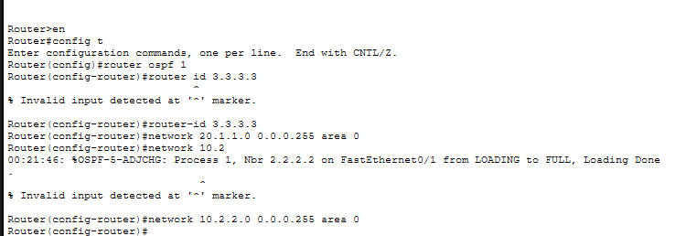
- Router 4
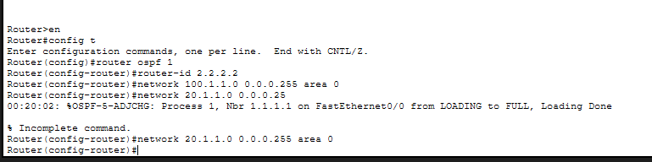

- Link State Analysis
Step 1: Neighbour Discovery
- Router 2
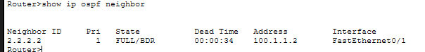
- Router 3
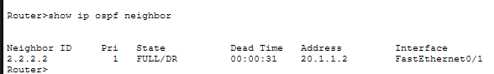
- Router 4
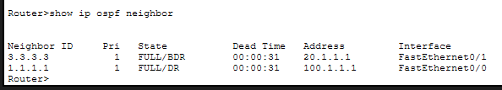

Step 2: Link State Database (LSDB)
- Router 2
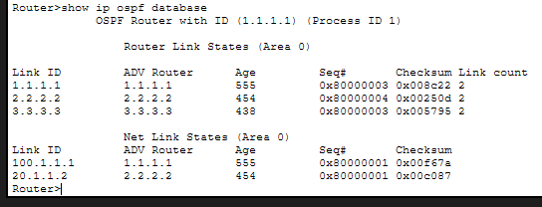
- Router 3
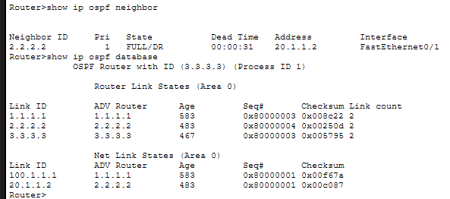
- Router 4
